This page has been made to help you with understanding the " sizing " of each of the types of needles. These pictures will also help you understand the difference between the different needles.
Millinery 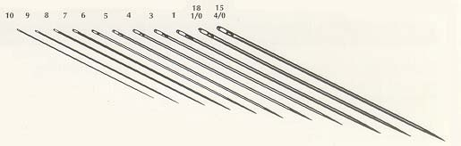

Darners 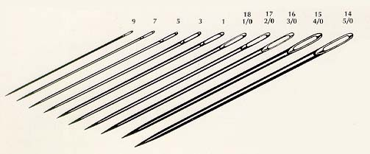

Embroidery Needles 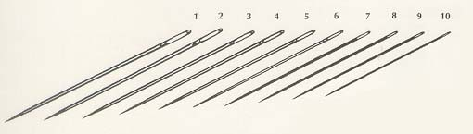

Long Darners 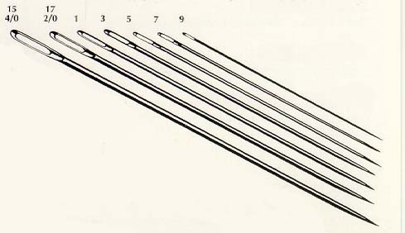

Tapestry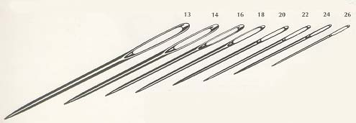

Chenille