In Patient Procedures

The date of surgery is confirmed according to the patient's convenience. The patient may select any type of available room. The patient may also decide, after consultation with the doctor, how long the postoperative stay should be. The length varies according to the condition of the patient.
Admission and discharge procedures
- When the patient is ready to undergo surgery, patient is counselled in the respective clinics or in the general counselling department.
- The patient is then directed to the admission counter where the full charge must be paid in advance. The patient gives consent for surgery at the time of admission. The inpatient record, continuation sheet and operation notes are attached to the patient's case sheet. The patient is assigned a room at the admission counter.
- The patient is sent to the respective ward duty room along with case sheet.
- In the ward, the co-ordinator enters the details of admission in the register and give the patient the assigned room key.
- The patient is given the medical prescription.
- The patient is sent for other required tests or procedures according to the type of surgery.
- Instructions for taking the medicine are given by the ward nurse.
- Preoperative counselling is done before the day of surgery.
- After surgery, the ward nurse visits every postoperative patient and gives the essential instructions.
- The ward coordinators on the respective floors provide postoperative counselling.
- The patient is discharged as per the instructions given by the doctor.
- Discharge summary is given to the patient at the time of discharge. Review date is assigned for follow-up of the eye condition.
- The patient is asked to settle bills at the discharge counter. Once the patient clears accounts the patient will be provided with a gate pass, which the patient hands to the security guard when the patient leaves the hospital.
- A reimbursement certificate is provided by the ward coordinators when the patient is discharged for those who must reclaim their money.
Amenities
Canteen facilities are available at the hospital. Food and snacks can be purchased there at nominal charges. The inpatients may also place orders with the hospital catering department for lunch, which will be provided in the room. The order may be placed with the catering staff, who come to the ward room every morning.
Visiting hours
Patient's guests are allowed to visit from 6.30 am to 9.00 pm. They should not bring children or persons with infectious diseases with them. They are not allowed to cook in the wardrooms. More than two attendants are permitted to stay in suite and deluxe rooms, two attendants in 'A' Class and only one in other rooms

Suit Room
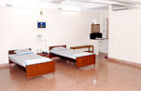 | 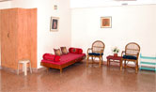
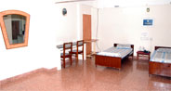 | 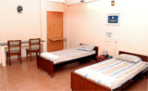
A Special A/C  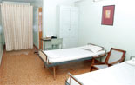 | A Special Non A/C  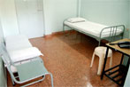
"A"  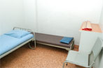 | "B"  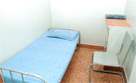
"C"
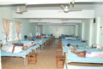
Source : Inpatient Procedures in www.aravind.org

